**Introduction to Web Development**

# Lab3

**Part2** – **Html Customer website**

**HTML semantic and non-semantic elements**

# 

**FORBIDDEN (grade for the lab automatically - 0):**

1. use ready-made templates/codes (cheating) from the Internet/groupmate etc.

# Deadline: 5 days

**INSTRUCTIONS**

**Perform each of the following activities**. If you have questions, issues, or doubts, please ask for help. Do not just guess.

1. Unzip the file **Lab3_Baseline.zip**
2. The Lab3_Baseline folder contains a file named Lab3_screenshots.pdf and Screenshot_Home.png. This PDF and png files contain screenshots of how our client wants their completed site to look. Use these screenshots as a guide while completing this project. The Lab3_Baseline folder also contains all of the text and images necessary to complete this project.
3. **Head Section Details:**
   1. This will be an HTML5 document, so give it the appropriate doctype and character set.
   2. This website contains four pages:
      1. index.html
      2. about.html
      3. parallax-way.html
      4. energy.html
   3. Give them the following titles:
      1. Parallax Global
      2. Parallax Global | About
      3. Parallax Global | Parallax Way
      4. Parallax Global | Energy
4. **Body Section Details:**
   1. Create a div with the id of “wrapper” inside of the <body> tag of each page. The contents of the web pages must be written inside of this body tag.
   2. Inside of the wrapper div, each page has the following structure:
      1. <header>
         1. <nav>
      2. <img class=”featureImage />
      3. <main>
      4. <footer>
   3. **Header Section Details:**
      1. Make the Parallax logo’s alternate text “Parallax Global”
      2. Give the links in the <nav> tag the following titles:
         1. Home
         2. About Parallax
         3. The Parallax Way
         4. Energy Holdings
   4. **Feature Image Details**:
      1. Give the feature image tag the following attributes:
         1. class: featureImage
         2. alt: Parallax Global
   5. **Footer Section Details:**
      1. The footer starts with a blockquote
      2. Under the blockquote, there are five addresses
         1. The address title gets wrapped in an <h4> tag
         2. The directions links have the following attributes:
            1. href: Use Google Maps links at the end of this document. They are not listed in any order, so make sure you place the link with its proper address.
            2. title: “Directions”
            3. target: “_blank”
         3. The Contact links have the following attributes:
            1. href: Use the email links at the end of this document. They are not listed in any order, so make sure you place each link with its proper address.
            2. target: “_top”
   6. **Main Section Details:**
      1. Home page:
         1. The headline is in an <h1> tag
         2. The embedded YouTube video has the following attributes:
            1. The video and its embed code are located here:

<https://youtu.be/nBPy6Q9NSW8>

* + - * 1. 560 pixels wide by 315 pixels high
        2. Privacy mode enabled
        3. No suggested videos shown at the end
        4. Do not autoplay the video
    1. **About page:**
       1. The Parallax definition is in a <p> tag. Do not forget to make the word bold!
       2. The headlines are <h1>, <h2>, and <h3> tags
       3. The image has the following attributes:
          1. class: ”floatRightImg”
          2. alternate text: “The Parallax Perspective”
       4. Assign the “South America” and “Middle east” table rows a class of “even”
    2. **Parallax Way page:**
       1. All of headlines are in <h2> tags
       2. The image is the first item in the unordered list, but it is not in a <li> tag. The image has the following attributes:
          1. class: “floatRightImg”
          2. alternate text: “The Parallax Team”
    3. **Energy Holdings page**:
       1. The headlines are in <h1>, <h2>, and <h3> tags
       2. The image of the map has the following attributes:
          1. id: map
          2. alternate text: “Map of the Sigsbee Field”
       3. Each of the four Integral component sections is wrapped in a div tag with a class of “infoBox” and one of the following id’s:
          1. Ojeda
          2. Arana
          3. Quiroga
          4. Orizba
       4. Each “infoBox” div contains the following items:
          1. An <h3> heading
          2. An image with the class of “floatRightImg” and one of the following alternate text attributes:

Ojeda Oil and Gas Processing Plant

Arana Oil Platform

Quiroga Oil Platform

Orizba Oil and Gas Platform

* + - * 1. A paragraph of text
        2. An <a> tag wrapped in a <small> tag. The <a> tag has the following attributes:

href: “#map”

title: :Go back”

target: “_self”

**Google Maps Links:**

<https://www.google.com/maps/place/55%C2%B046%2710.1%22N+37%C2%B035%2749.4%22E/@55.769469,37.597066,15z/data=!3m1!4b1!4m2!3m1!1s0x0:0x0>

<https://www.google.com/maps/place/48%C2%B052%2724.0%22N+2%C2%B017%2749.6%22E/@48.873327,2.297117,15z/data=!4m2!3m1!1s0x0:0x0>

<https://www.google.com/maps/place/1%C2%B018%2704.2%22N+103%C2%B051%2716.3%22E/@1.301155,103.854528,15z/data=!4m2!3m1!1s0x0:0x0>

<https://www.google.com/maps/place/40+E+73rd+St/@40.772068,-73.964603,17z/data=!4m2!3m1!1s0x89c258eb4d838235:0x2220aa41e00eb8ce>

<https://www.google.com/maps/place/51%C2%B030%2736.6%22N+0%C2%B008%2706.6%22W/@51.510165,-0.135173,15z/data=!4m2!3m1!1s0x0:0x0>

**Email Links:**

<mailto:paris@icarnegie.com?Subject=More%20Info>

<mailto:london@icarnegie.com?Subject=More%20Info>

<mailto:newyork@icarnegie.com?Subject=More%20Info>

<mailto:singapore@icarnegie.com?Subject=More%20Info>

<mailto:moscow@icarnegie.com?Subject=More%20Info>

# !!! Send all your code and picture in one zip file (name surname group_number) to dl.

# Upload your code into a Github repository

**For next lab**, read, watch videos and also make notes from here except Coursera: <https://learn-the-web.algonquindesign.ca/courses/web-dev-1/week-05/>

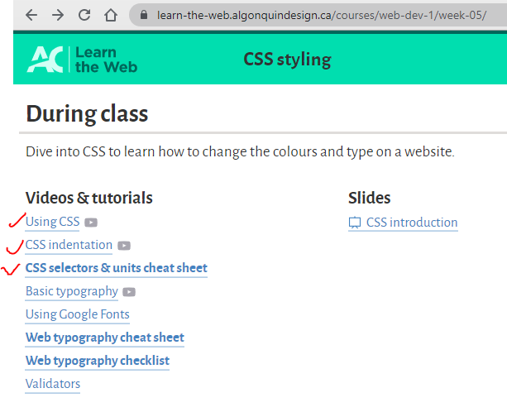

**Additional info:**

* Every time **check your HTML code for errors** before sending it to the teacher or upload to Github. Use <https://validator.w3.org/>

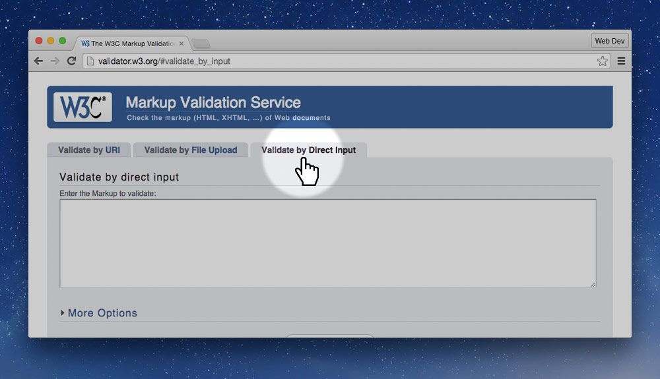

1. Select all your HTML code
2. Copy the code
3. Go to the [W3C HTML validator](https://validator.w3.org/).
4. Paste the code into the “Validate by Direct Input” text box
5. Press “Check”.
6. See your errors, correct them, and validate again.

You want to get the green bar—green is good.

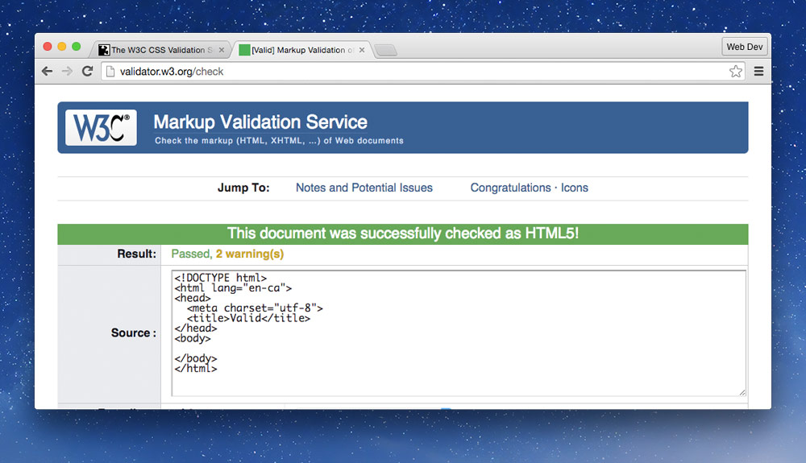

* Use **WAVE® Web Accessibility Evaluation Tool**

It helps make your web content *more accessible* to individuals with disabilities

* MUST Follow this **folder structure** from your next lab.

